**Manoj M**

**manumadhu1425@gmail.com**

**Developer days**

**UI and UX week 1 challenge**

1. Information architecture map:

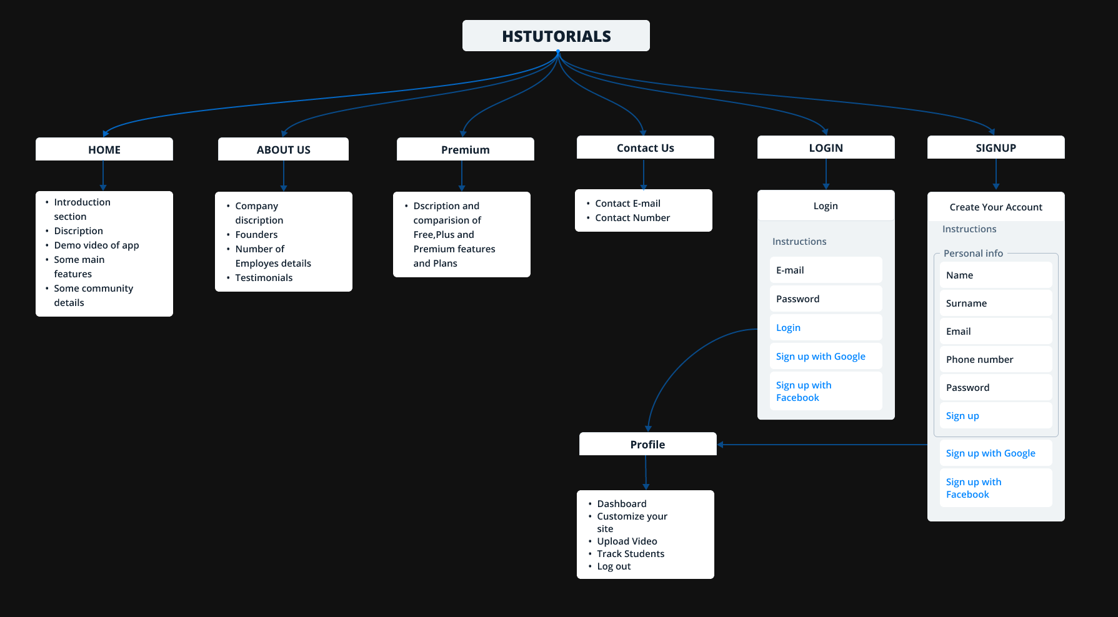

1. 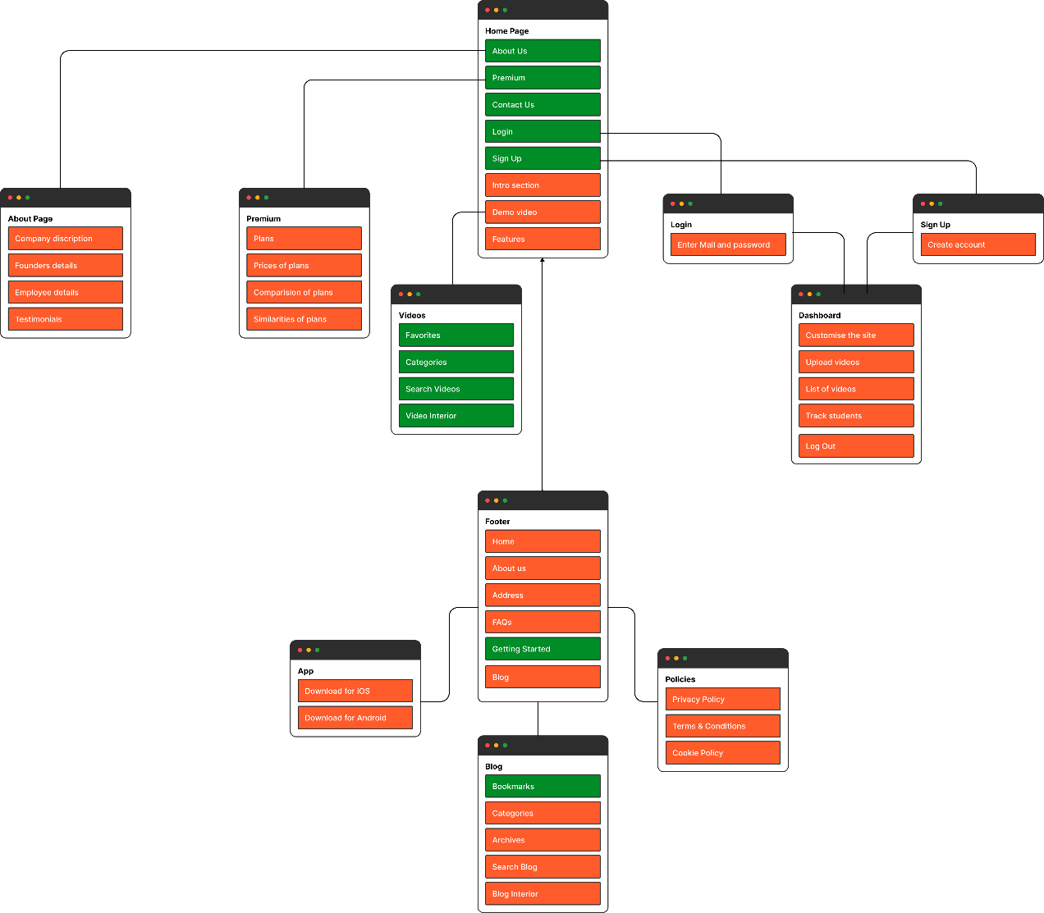Sitemap:

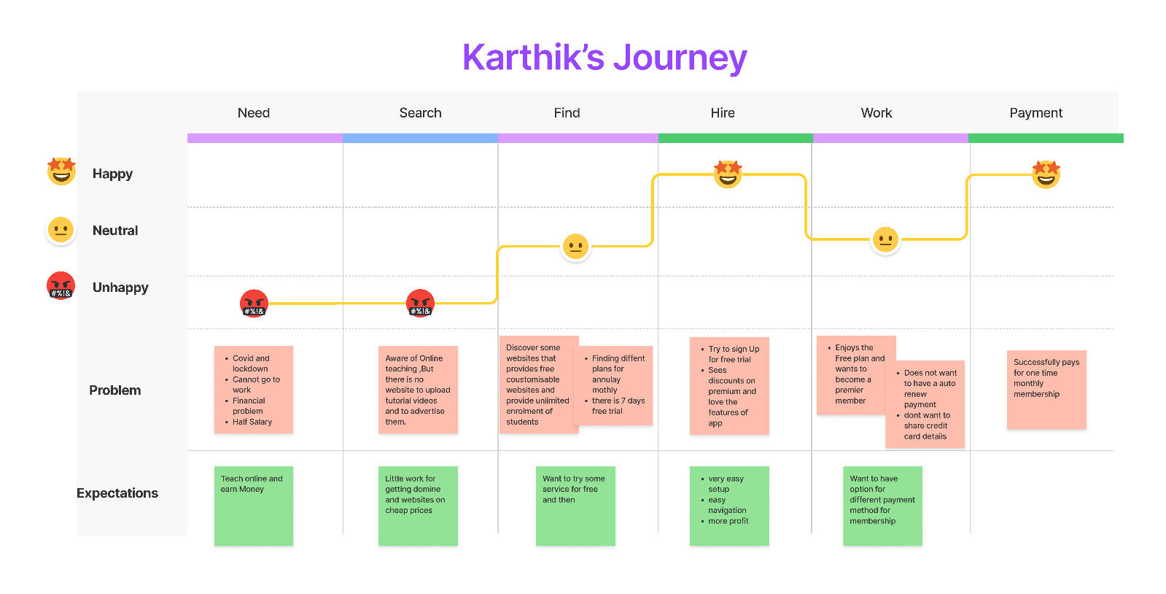3 User journey Map:

1. Non visual Prototype:

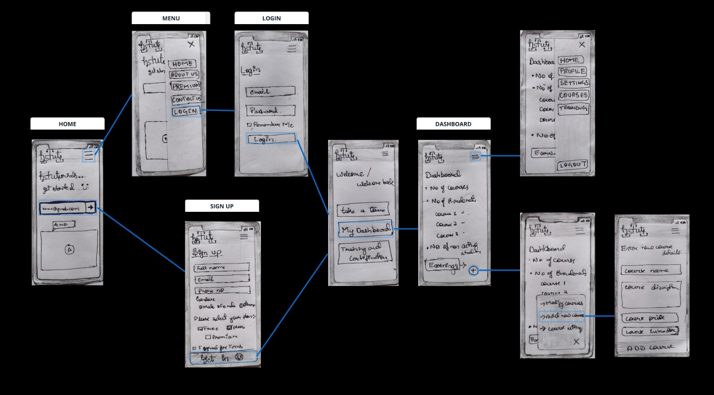

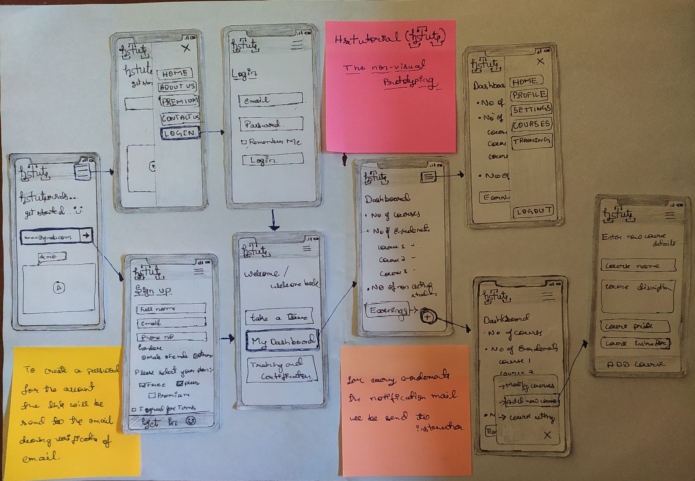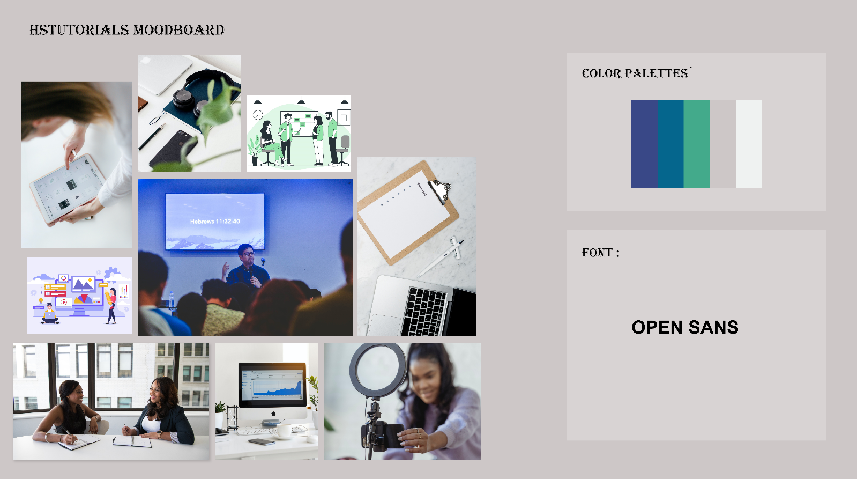

1. Moodboard, Colour Palettes, Font: